Module 4 transcript
Wealth On Any Income

How to Live Within Your Income in 90 Days Guaranteed (By Using the Tools!)
Spending Register
Referral Script for business building

In Module 1, I said you would be provided with tools to make powerful new decisions. With these tools, you can make choices about who will be getting your money and determine if you’re getting the level of pleasure you’re paying for. I like using the term “tools.” Generally, tools are the forms and concepts provided which will allow you to create financial independence. If you don’t like the word tools, you can use something else like “keys,” But if you wanted to prepare a gourmet meal you would need cooking tools
What’s another word for cooking tools?
Utensils
What are some examples of utensils?
Knife, spatula, grater, pot, pan and so on.
What kind of tools would you use if you wanted to repair an automobile?
Wrench, screwdriver, pliers…
You wouldn’t expect to build a house with your bare hands, would you? So these forms and concepts are the tools that will allow you to build your financial house and attain financial freedom. This house will shelter you from fear, anxiety or concerns regardless of the economic conditions around you.
If you remember, in Module 1 we covered thinking from the details or the big picture; we covered the three areas we all operate from; thoughts, feelings or values, and how feelings run us most of the time. But tapping into our values can overcome the feelings that can get in the way of our financial success. And when we listen to familiar information are we making statements or asking questions? I’ve also heard this described as the “Yes, but…” disease.
Let me hear from any of you what the “Yes, But” disease might sound like.
In Module 2 we did a word exercise to measure your relationship to either poverty or prosperity thinking; we discussed our belief systems about money based on messages we may have received when we were young; we did another exercise for couples to understand each other’s money values; you wrote a 5 year financial goal, from the future; and finally we covered the 6 areas of influence from the book Change Anything to build a support structure that you will use to guarantee your success in the achievement of your goals.
I recommended that you re-read your 5 year goal to be sure it’s a fit for you and your values and suggested creating milestones from 1 day, 1 week to 1 month on your goal.
In Module 3 we covered the Debt Elimination and Memory Jogger forms and two of the powerful financial tools used by the wealthy; the Balance Sheet and the Income and Expense form. These are also the tools the wealthiest people in the world use, and I hope you saw you don’t need any financial background to complete these forms. These forms measure how you’re winning the financial game of life, to see if you’re on track toward your goals or to determine if you’re getting what you paid for. They work for the wealthy and they will work for you.
Tell me what new insights were seen from completing either of these forms?
As a reminder, we spent the first two modules dealing with the emotional components and our attitudes about money. And the point of doing the emotional stuff first, like how we listen; whether we’re operating from our feelings or our values, the belief systems we have; setting our five year financial goal and so on, is to create the desire to put these tools into practice.
Today we will cover the Spending Plan Register and the most powerful way to ask for referrals for new business. After creating the content for this module, I realized I was trying to pack 2 pounds of food in a 1 pound can; …it wouldn’t fit the time frame, So, the points I said I would cover in the conference call invitation have to be split up. On our next call, which will be in two weeks, not next week, we will cover the Pay Yourself First concept and a Spend versus Keep allocation for your money.
The Spending Plan Register is used in two ways. First it will create awareness on where your money is going so you can have a reality check on your spending.
Give Overeaters Anonymous example of tracking food by writing it down.
The second way it’s used is to spend money in alignment with your goals. The Financial Coach Spending Plan Register is the last, and one of the most powerful tools to create financial freedom. It’s a very flexible tool and if you use it as I suggest, you can live within your income in 90 days. I guarantee it! You can see how close you are to any savings or spending goal in 5-10 seconds without the aid of a computer or phone app. If you have one of those, you are welcome to use it. And we will discuss the awareness that shows up from tracking the results of your spending each week until the end of the course.
And it doesn’t matter if you use this tool that I emailed over the weekend, or you have an app on your phone, or you use Quickbooks, it’s the CONCEPT that is most important.
As I was working on this module, it felt like I was going to be doing too much talking with too little interaction, but I hope you can hang in with me on this concept. This is how one attorney was able to find $12,000 that he needed to pay his income taxes. If you already have a process to get this same information, then you might want to add the concept of measuring your pleasure to what you’re doing now, if you’re not already doing that. Most of what I will cover here is directly from the Wealth On Any Income book.
One day I was watching TV and ran across a program on the life of John D. Rockefeller. This is the man who established the Standard Oil Company and at one time was the richest man in the world. The TV program showed a ledger (or register) he used when he was eleven years of age. In it, he tracked every penny that came into and out of his life, where it came from and where he spent it. These are the habits of the wealthiest people in the world and you can use them to transform your life. It’s not about penny pinching. It’s about consciously choosing where you will spend your money, measuring the level of pleasure it provides, and spending in alignment with the results you want to produce in your life. Your spending will be based on your values, not the values of your neighbors, co-workers or politicians.
The Spending Register will let you know in 5 to 10 seconds how much money you will have available to spend in any category you choose to track, without using a computer! In addition, you have the opportunity to measure your pleasure: You will be able to see if you’re receiving the level of pleasure you are paying for based on the questions you can ask as you make a purchase.
Last week you either guessed, or used your financial records of expenses, to determine if you have a positive or negative cash flow on the Income and Expense form. Now it’s time to verify the figures. In addition to the version I emailed, in the back of the book I provide two pages of The Financial Coach Spending Plan Checkbook Register you can tear out and copy.
There are two ways to use this form in the following example. Also, refer back to the Spending Plan Cash Flow Memory Jogger for assistance in setting up categories for yourself.
When you fill out The Financial Coach Spending Plan Checkbook Register for the first time, use it find out where your money is going. Simply pick from any of the categories on the Cash Flow Memory Jogger for the category where money leaks out during the month. It may be meals out, groceries, clothing, transportation expenses or entertainment.
You don’t need to use the register to write down your rent or mortgage payment. After all, once you’ve paid this, it doesn’t show up again for another month.
In the example that I also emailed, I use the categories Meals Out and Groceries to illustrate the primary two ways the register is used. A third use is to show how well you’re saving up for something. When saving up for something, like a $10,000 vacation, put the goal at the top. As you set aside money toward this, subtract from the goal to see how much you have left to save.
So let’s look at the examples provided. First you’ll notice for Meals Out, on January 1, I spent $10 for lunch. It was cash. And if it’s cash, you don’t have to write that down, you can leave it blank, and that means you used cash. I have the room for notes to show who I had lunch with, and this is also valuable at tax time. When I’m having business meals it can be noted here. In my register, I actually kept two separate columns, one for personal meals and one for business meals. You can structure your own register to gather any data you want.
It’s so simple to keep the records because it was right with my checkbook that I always carried. A client of mine used to wrap his cash in the register like a money clip. He used more cash, and I used more checks. Or if you use a debit card, place that in the register.
I don’t have to wait until I get home and load it in some computerized money tracking, budgeting or check writing program to have some answers. I don’t have to fumble around in a three-ring binder, iPhone, Blackberry, or Franklin Planner. It’s right where the money came from. If you choose to use a program on a “smart phone” that’s fine. Just make a notation with every single expenditure right then and there.
So, if I spent $10 having lunch with Bill I write it in the column. Let’s say the next day I use a credit card at lunch and charge $22 on Visa. I put a circle around the $22 because this identifies money I spent that wasn’t cash. At any time I can go through my register and, by adding up all of the circled items, I know how much will show up on my credit card statement when it arrives in the mail.
For the Smith business lunch, I add the $22 to the $10 I spent previously.
How much have I spent so far?
$32 in Meals Out. The shaded area is for additional notes and the subtotal. The next day I go out to dinner and charge $26 on my American Express. Again, I circle the number.
So, what’s my total in Meals Out?
Now I see I’ve spent a total of $58 in Meals Out.
Did anyone catch the error on this page in the book? It says $56.
On the fourth, I write check #123 for a dinner with my wife. I spent $22. You can see I’ve spent a total of $80 in Meals Out. It’s just that simple. I write it down and add it up. It takes no more than 5–10 seconds after each expenditure.

Now I want to prove this takes less than 10 seconds to create the information from which you can make decisions. Just take out a piece of paper; you don’t have to use a blank Spending Register to prove my point. I will tell you to write down some items and I will time you.
Write down the word cash, then lunch, then $15.00
That should have taken 6 seconds.
Now write down the following: cash, dinner, $25 and add that to the $15. You should have $40 and it should have taken 10 seconds.
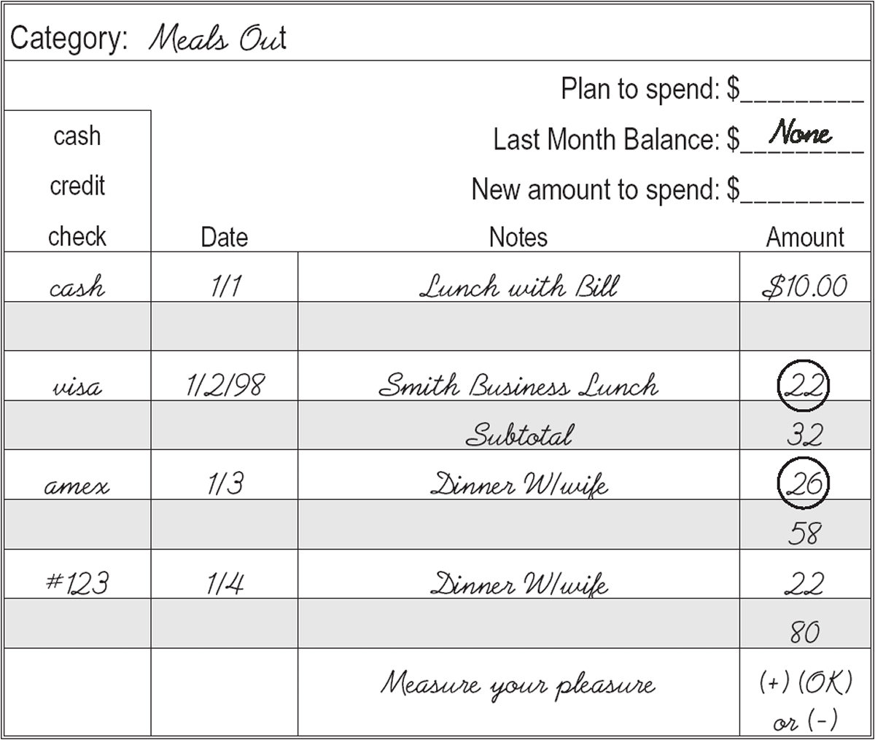

Are there any questions about this so far?

In the book Your Money or Your Life, two key concepts are presented. In the first, money is converted to life energy you’ve used up. You can convert any income level into an hourly rate and use that hourly rate to measure the cost of items you purchase. As an example, a common work week of 40 hours would be 2000 hours per year. If your annual income were $60,000, you would reduce it by the taxes you pay and the other deductions from your check. You would then add up the additional hours you spend related to your work, such as driving to and from, bringing work home, buying or cleaning work clothes, and so on and add that together to establish the real total of hours you spend related to your work. In this example, I could add another 250 hours for those work related items and end up with a total of 2250 hours.
At $60,000 per year I would be at $30 per hour. After taxes I would be at $25.50 per hour. And at 2250 hours I’m really at $22.60 per hour. Now I have a real number to use to measure the value of my purchases.
In this example you are trading each hour of your life energy for $22.60.
The next step is to use the concept of asking questions. You use the hourly rate of life energy given up to Measure the Pleasure you get for the money you spent. As an example, repairing your car for $900 isn’t spending $900. It’s giving up 40 hours of your life to repair the car. Now, you ask questions like, “Did I receive pleasure and value based on how much I spent?” “Is this expense in alignment with my values?” “Would I spend money in this way if I didn’t have to work for a living?” I also suggest you do this for items you don’t track, like rent, mortgage or car payments.
Here are some additional questions you can ask for other purchases:
- How long have I wanted this and seriously considered its purchase?
- Did I want this before I saw someone else with something similar?
- The last time I purchased a similar item, how long did my enjoyment last?
- If I finance or charge this item, will I still be paying for it after the pleasure is gone?
- Can I postpone this purchase for a month without causing harm, discomfort or inconvenience to myself or others?

Based on your answers, you put a rating at the bottom of the various expense category columns.
If your answer is positively strong put a plus (+) sign at the bottom of the spending plan column or next to the payment in your checkbook. If it was fine at its current level, put “O.K.” If it was unsatisfactory, or you would like to see it decrease, put a minus sign (-). You can measure a whole category, or item by item; it’s your choice.
Who is the one who decides if something was worth the purchase price?
Now that you’ve discovered where you’re spending your money by writing it down in The Financial Coach Spending Plan Register, you’re ready for the second and primary way it’s used. This is shown in the Groceries column. Here I decided I only need, or choose, to spend $300 on groceries. I arrived at this figure based on finding out what I usually spend on groceries and the level of pleasure that amount of money provides to me. I used the system described in the previous paragraph.

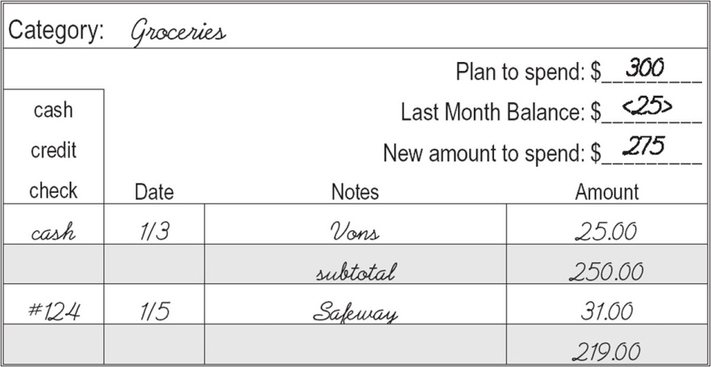

You’ll notice where it shows last month’s balance there’s a negative $25. This means in the previous month instead of spending $300, I spent $325. What I do is subtract $25 from the $300 I planned to spend. I am only going to spend $275 the following month. I guarantee you can live within your income in 90 days if you use this tool as described.
There is another way I could handle the $25 shortage. If there was money left over in another category, like Entertainment, I could reduce the amount I plan to spend there and transfer some of that money to the Groceries column, or vice versa.
On January 2, I spent $25 at Vons. I subtract that from my $275 and have $250 left. The next day I write a check to Safeway for $31. I now have $219 left. By doing this, instantly, I know how much money I have left to spend on groceries, or any category I choose to track.
Let’s say it’s half-way through the month, I buy some groceries and I have $100 left. Right then and there, immediately, I know I’ve got to slow down. I’ve got one-third of the money left and half the month to go. This tool yields instant information on where your money is going and how much you have left to spend in any category you choose to track.
What I found out was that I want to eat meals out. I don’t want to buy groceries. Again, you will find a sample of the Spending Plan Register in the Appendix of the book I provided that you can tear out and use.
If these habits benefited the wealthiest people in the world; could they be of benefit to you too?
Here are some valuable, helpful and powerful guidelines when it comes to spending or borrowing money:
1. How long have I wanted this and seriously considered its purchase?
2. Did I want this before I saw someone else with something similar?
3. The last time I purchased a similar item, how long did my enjoyment last?
4. If I finance or charge this item, will I still be paying for it after the pleasure is gone?
5. Can I postpone this purchase for a month, without causing harm, discomfort, or inconvenience to myself or others?
When you’re excited about buying something expensive, and YOU determine what that is. For one person it could be $80 pair of jeans. For another it could be a $300 pair of jeans. It could be a new car, bicycle, addition to a hobby, whatever, DO NOT MAKE A DECISION THAT DAY. Wait two to three days for small purchases. Wait one to two weeks before making a decision on a large purchase.
When you are stressed or in fear, you cannot make a good selling decision, like you’re behind on a mortgage, rent payment, car payment, a stock has declined due to a market crash, etcetera. In those situations do not sell an asset when influenced by fear, scarcity or lack. Next, before selling, speak to an expert, like your CPA, an attorney, or “neutral” investment advisor. It’s best to get input from at least two experts and three would be preferred. This will also take the time that will allow you to cool down.
Finally, do not borrow money when you are either excited or afraid.
Please let me hear what questions or concerns you have up to this point.

Referral Script for business building:
Now I realize the next area for us to discuss is not a fit for the flow of tracking your spending before I move on to the next financial concept, but we need to have a break from my talking and have participation from you.
As far as I can tell, all of you who are participating in the course are responsible for generating your own income. Whether you are in real estate, lending, coaching or whatever, many of you are doing work, or are in a business where referrals are, or can be, a substantial part of how you can gain new clients or grow your business.
What I want to discuss is one of the most effective methods of asking for referrals, and it doesn’t matter if you are just starting out in business or you’ve been in business for 40 years.
But first, let me ask anyone on the call how you would ask for a referral to grow your business.
I forgot to mention that this program is participatory. It can’t just be me doing all the talking.

The following is something I’ve used for decades, and it works superbly. I discovered it about 30 years ago after it was tested over dozens of other scripts used over thousands of calls by professional telephone marketers. It’s so short, and so simple, it’s amazing. And it produced three times more referrals than any other script that was tested. Here it is, word for word, so write it down exactly, exactly, as I read it to you. It starts with “I’m growing my business and I need your help.”
Now if someone is looking for their first client, would it be accurate to say they are growing their business? This is where you still participate.
If they’ve been in business for 40 years, could it still be an accurate thing to say?

So then it doesn’t matter what stage of business someone is in, it’s accurate. The last part of that sentence uses the word “help.” You’re not asking for their support. You’re not asking for their partnership, guidance or influence, you’re using the word help that establishes a situation where the person you are asking is superior to you. They have something you don’t have, and they can help you.
When someone asks you for help, how does it make you feel?
There is one more sentence we add to get exactly what we are looking for. When I learned this script I was selling financial services and life insurance. Let me ask you this; if I said I’m growing my business and I need your help. And then asked, “Who do you know who needs life insurance,” what do you think the answer would be?
So the next sentence starts with who do you know who, but ends with a description of the prospect you’re looking to meet. So write down who do you know who and then we will describe the person you are looking for as a referral. When I started in the insurance business I was taught to make cold calls. That lasted about 9 months before I was burnt out. So when I discovered this everything turned around. In my insurance example I would ask, “Who do you know who has a profitable business with about 5-10 employees”? Or, who do you know who just bought a new home or a new business? Or, who do you know who would be a key person in the success of a small business? Or, who do you know who that you would guess is worth more than $5 million dollars. Or, who do you know who drives a luxury automobile?
So if my target market is new homeowners, or business owners, or wealthy people, I’ve described people that need life insurance and can probably afford the premiums.
How would you describe the prospect you would want for your business?

On our next call, we will cover the concept of Pay Yourself First, which shouldn’t be new, especially if you’ve read my book. And again, it will be interactive. I will need your participation.
I will present a simple structure to handle emergency expenses without creating a financial disaster or using credit cards. What money to spend, and what money to keep forever.
We will skim the surface on the types of investments where you can earn 8 to 10 times more return than the banks are paying.
And, between now and our next call, please track your spending and we will discuss the insights you gained over those two weeks. Track the things like meals out, entertainment, parking, auto expenses, like fuel or any repairs, clothing purchases for you or family members, office supplies or outside services, and so on. Again, you don’t need to track one time payments like an auto lease or rent.
Finally, please call 3 clients before our next call and use the referral script. Report the results to me on the Facebook page or send an email to me.
Don’t forget about the Facebook group to check in with one another, make commitments, allow someone else to hold you accountable, or ask questions or ask for support. I sent invitations to a few of you, and got a pop up message that I was not allowed to invite you. I’m guessing you may not have a Facebook page.
Goodbye everyone.

There's a saying... success leaves clues. And Jeff Walker became a master of following those clues. Along the way, he’s met dozens of millionaires and multi-millionaires. And the thing he noticed is that EVERY SINGLE ONE of them studies those success clues as well. They are all students of personal development. The fact it, you have to get your inner game working right before the outer success comes.

